#### Objective

You will implement the functionality which features regular updates of a cricket match on a Telegram group.

#### Project Context

Cricket fans, raise your foam fingers if you have been looking for a quicker way to share scores and updates with your friends. Even if you aren’t a sports enthusiast, think about the number of fans who are out there looking for an option like this on their phones. Sports websites do offer live scores on their page which is what the majority of the people follow to stay updated on live updates if they are not watching a match.

But the thing with these websites is that you have to keep staring at the page or refreshing it to get the latest score which can be quite unproductive if you are in the middle of important work. Moreover, every time you want to share the joy of a SIX or a wicket with your friend, you have to manually share it via a messaging app.

But now, you can build a better solution for the millions of sports fans (including yourself if you raised your foam finger) and even learn important concepts in that process.

#### Product Architecture

This Product Architecture consists of 4 stages as follows:

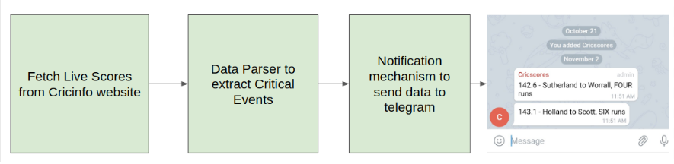

#### High-Level Approach & Flows

* Get the live score

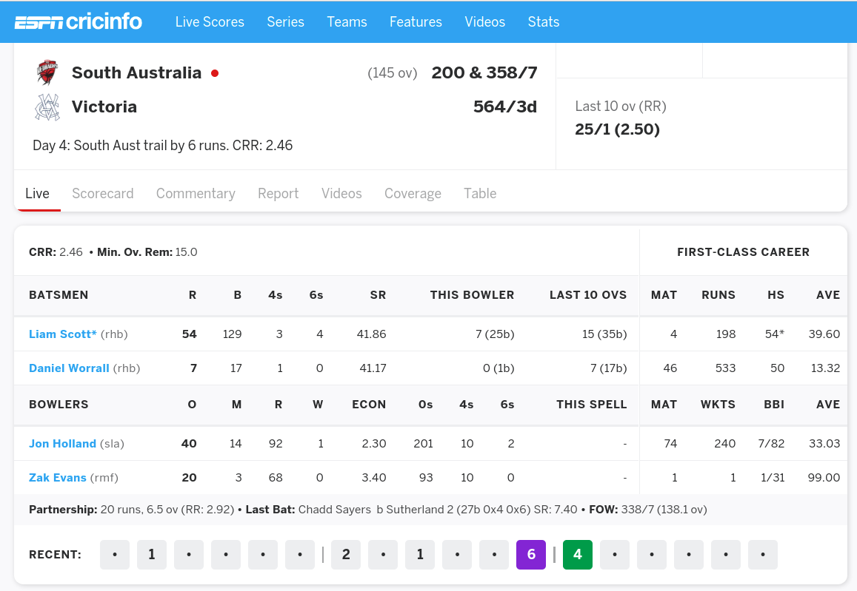

* Extract critical events

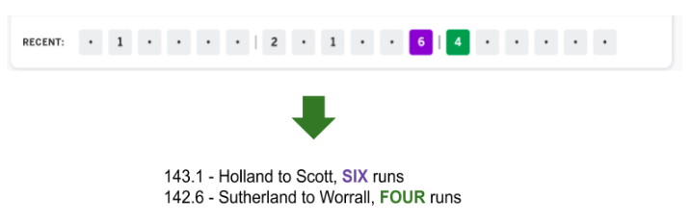

* Notification to Telegram - This is the output which is the result of this project.

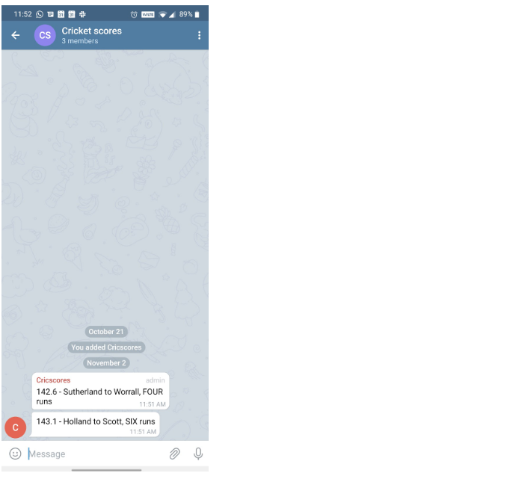

#### Primary goals

* Build the Score Alerts functionality from scratch using python
* Compile, test the functionality and publish

#### Pre-requisite skills

* Python

#### Post Project Skills

* REST
* HTTP
* Jackson

#### Proof of Concept

First validate the idea by doing a low level implementation (Proof of Concept) of the components involved in the project.

This helps you to:

1. Get more clarity around the unknowns.
2. Get a better understanding of the stages involved in the project.

### Requirements

* Explore "<https://www.espncricinfo.com/>".
* Select a scoreboard of a match and inspect elements to figure out the api which is responsible for the showcase of scores.
* Checkout the response of the API.
* Understand about the telegram bot and the APIs used for sending messages and receiving updates.

### References

* [REST](https://learn.crio.do/home/me/ME_REST)
* [HTTP](https://learn.crio.do/home/me/ME_HTTP)
* [Jackson](https://pypi.org/project/JackSON/)
* [Chrome dev tools](https://www.bitdegree.org/learn/chrome-developer-tools)

### Expected Outcome

The idea of this Milestone is that you should explore all the components which are to be stitched together in the upcoming modules